Camp 2020 Review
Name:

Themes (Farm, Zoo, Outdoors, Aquarium, Outer Space)

I liked | I did NOT like | It was okay.
My favorite one was...

Comments: (wow, awesome, cool, boring)

Learning Activities: (Charades, Guess Who, Guess What, I Spy, Reading books, Storyboardthat.com, etc.)

I liked | I did NOT like | It was okay.
My favorite one was...

Comments: (wow, awesome, cool, boring)

Modeled Activities: (Scavenger Hunt, Flat Clinician, Fishing, Nature Art, Paper Spaceship, Shooting Stars).
I liked | I did NOT like | It was okay.
My favorite one was...

Comments: (wow, awesome, cool, boring)

Live Zoom Group Sessions:
I liked | I did NOT like | It was okay.
My favorite one was..

Comments: (wow, awesome, cool, boring)

Live Individual Zoom Sessions:
I liked | I did NOT like | It was okay.
My favorite one was..

Comments: (wow, awesome, cool, boring)

Specials (Yoga, OT, Zumba, Music Therapy, Cooking, Science)
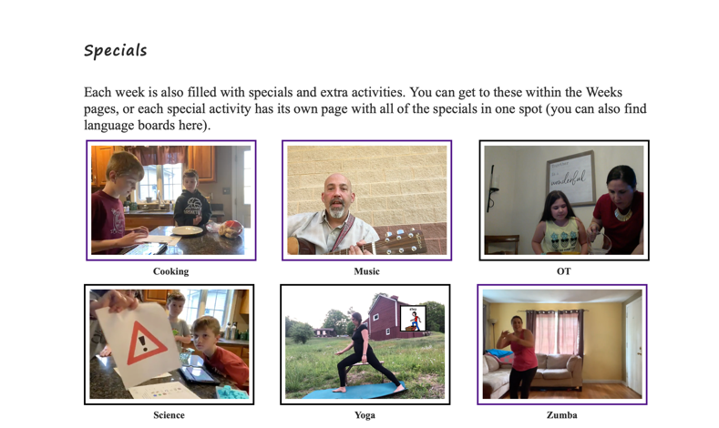

I liked | I did NOT like | It was okay.
My favorite one was..

Comments: (wow, awesome, cool, boring)

Any other Comments:

